MY PROLECT SCREENSHOTS

MY database when i was store some basic nutrition information
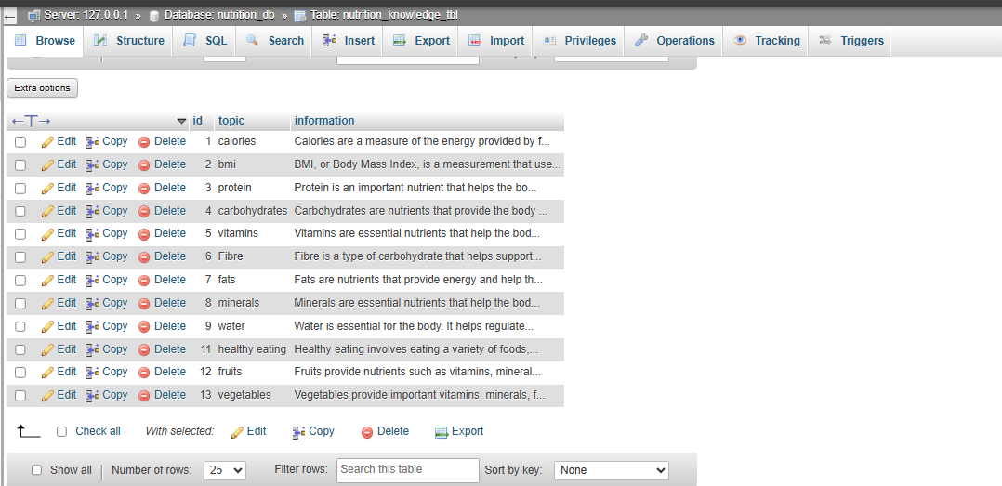

The chatbot interface when it still respond from the app.jsx file
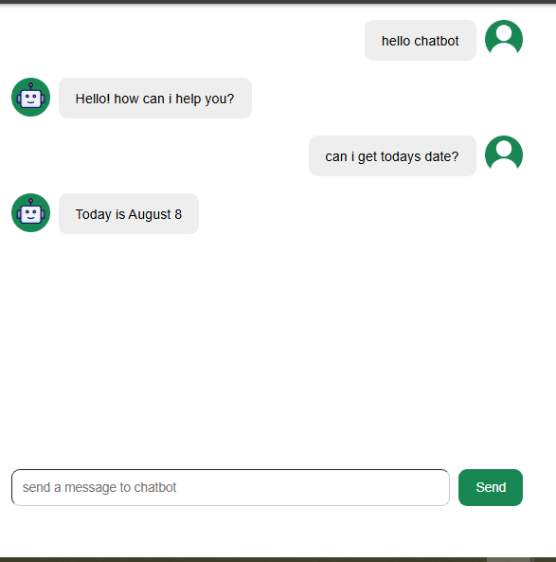
The Chatbot when it beginning o respond with what i store in the database

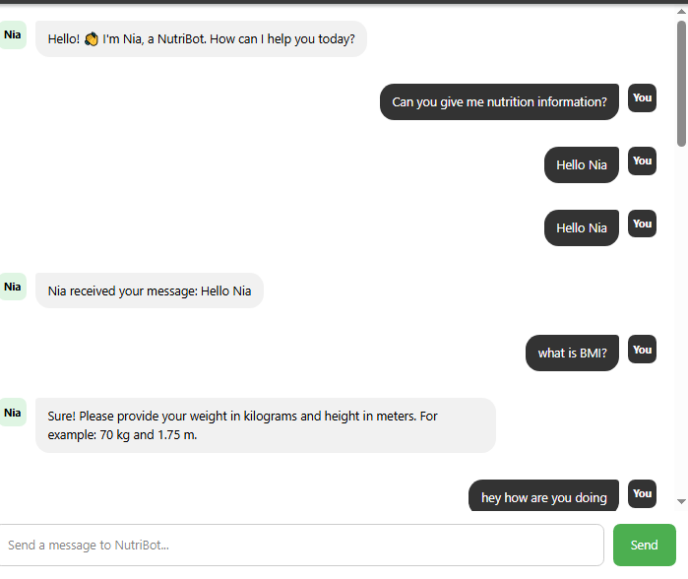
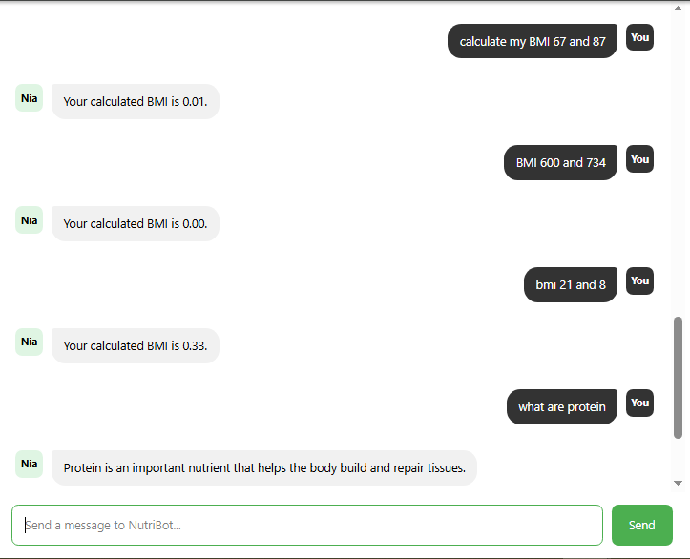

THE PROJECT ARCHETECTURE
NUTRIBOT
│
┌─────────────┴─────────────┐
│ │
React Frontend User Input
│ ┌────────┼────────┐
│ │ │ │
│ Text Voice Image
│ │ │ │
└──────────────────┴────────┴────────┘
│
▼
Node.js + Express
│
┌─────────────┼──────────────┐
│ │ │
▼ ▼ ▼
Chat API Food API Hospital API
│ │ │
▼ ▼ ▼
Python/FastAPI MySQL Location/Maps
│
▼
AI / LLM
│
▼
Vector Database

FOOD TABLE IN THE DATABASDE
Column | Type | Purpose
id | INT | Unique ID for each food
name | VARCHAR(100) | Food name
category | VARCHAR(100) | Food category
calories | DECIMAL(10,2) | Calories
protein | DECIMAL(10,2) | Protein
carbohydrates | DECIMAL(10,2) | Carbohydrates
fat | DECIMAL(10,2) | Fat
fibre | DECIMAL(10,2) | Fibre
vitamins | TEXT | Vitamin information
minerals | TEXT | Mineral information

